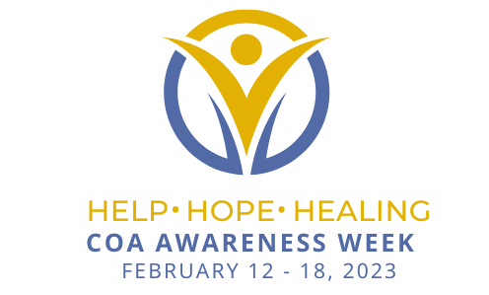

Join the  international awareness campaign to break the painful silence and offer hope to the vulnerable kids and teens impacted by parental addiction.  Addiction is a national health epidemic – not resting during the recent rage of an international pandemic – and communities across the country are struggling with ever-increasing drug overdoses and demands for more treatment options for those with addiction. Child welfare programs continue to be overwhelmed because of addiction. The impact on children today is staggering. While some children can find a supportive adult who helps protect them from the worst, others may be alone and without hope that healing is even possible. We cannot afford to forget the countless children – those who are often the first hurt and last helped by this devastating disease.

**Download COA Awareness Week resources to spread awareness, educate your community, and support children and young adults impacted by addiction. Help us to make a difference to last a lifetime!**

* [**2023 COA Awareness Week Flyer**](https://nacoa.org/wp-content/uploads/2022/12/Flyer.COAAwarenessWeek2023.pdf)
* [**2023 COA Awareness Week Social Media Toolkit**](https://nacoa.org/wp-content/uploads/2022/12/COA-AWARENESS-WEEK-Social-Media-Toolkit.2023-1.docx)
* [**Why COA Awareness Week 2023**](https://nacoa.org/wp-content/uploads/2022/12/Why-COA-Awareness-Week-2023.jpg)
* [**2023 COA Awareness Week Activities**](https://nacoa.org/wp-content/uploads/2022/12/2023-COA-Awareness-Week-Activities.pdf)
* [**Impact of Alcohol/Opioid Use Disorder on Children**](https://nacoa.org/wp-content/uploads/2022/12/ImpactedKids.COAAwarenessWeek2023.jpg)

*Subscribe to receive updates and additional materials for COA Awareness Week 2023!*